### 

### **Table of Contents**

**Executive Summary 2**

**Introduction 2**

**Test Hypothesis and Ad Design 3**

**Consumer Behavior Theory 4**

**Target Audience 5**

**Campaign Execution / Procedure 5**

**Results & Performance Analysis 6**

**Research Constraints 7**

**Conclusion 8**

**Future Recommendations 8**

**References 10**

**Appendices 11**

### 

### **Executive Summary**

This campaign is a collaboration between Scones & Doilies, a premium bakery in the Greater Lafayette area specializing in handmade scones and cakes, and Purdue University to improve Instagram engagement for the store. The primary goal was to increase profile visits using A/B testing to compare two ads: both focused on product quality, but one featured a Yelp review and the other a simple product description. Based on Expectancy Theory, the campaign aimed to assess how different messaging influences user behavior across age and gender segments in the Greater Lafayette Area. Performance was measured through metrics like clickthrough rate, reach, frequency, and overall actions taken. Results showed that the test ad outperformed the control ad (3.5% vs. 2.2% CTR respectively), and particularly among young men (25–34), where it achieved a 21.5% click-through rate versus 0% for the control. The campaign generated 43 new Instagram followers and drove greater page engagement. The impressions were skewed toward women and younger users, limiting insights for older groups and men. Despite this, the campaign demonstrated that review-based messaging can significantly enhance engagement and provided actionable guidance for future advertising strategy.

### **Introduction**

Scones & Doilies is a locally-owned premium bakery located in downtown Lafayette. It’s known for its handmade scones, cakes, and pastries inspired by traditional European recipes. The owners, who are originally from Europe, bring an authentic touch to every item they bake. Their business has been slowly growing through word-of-mouth and local support, but with the rise of digital media, they’ve been exploring how to reach more customers online—especially through Instagram, which is where a lot of their visual content naturally lives.

In this project, we partnered with Scones & Doilies to help them improve their Instagram engagement, specifically profile visits. To do this, we ran an A/B testing campaign that compared two types of ad messaging: one that focused on product quality through simple and descriptive text, and the other highlighting the product quality by featuring a glowing Yelp review. By running both ads to different groups and analyzing the results, we hoped to figure out what type of messaging works better for different types of customers.

The framework we used to guide this analysis was Expectancy Theory, which is a motivational theory that states that people are more likely to take an action when they believe it’ll lead to a positive result. In this case, the Yelp review acts like a signal—it tells potential customers, “Hey, other people tried this and loved it,” which should increase their confidence in the product and make them more likely to visit the page or the store.

Our goal with this campaign wasn’t just to get more clicks, but to actually understand which message resonates better with different age and gender groups. We wanted to see if a straightforward message about product quality works better, or enhance Expectancy & Valence through a Yelp review that has more of an impact on engagement. This kind of insight can be really valuable for a small local business like Scones & Doilies that doesn’t have a huge marketing team or budget at hand. If we can help them figure out what kind of content makes people more likely to click, follow, or even visit the store, that can guide how they approach their future Instagram posts. It’s not just about one-time results but building a strategy that fits better with the audience. Also, since Meta gives data by age and gender we could analyze how different types of people respond to each ad. Overall, the goal was to blend data and marketing psychology— Expectancy Theory—to give them insights that are both actionable and tailored to how their audience actually thinks and behaves.

### **Test Hypothesis and Ad Design**

1. **Hypothesis**

Our hypothesis is that including a 5-star review in the test advertisement will increase consumer engagement with the ad. Grounded in expectancy theory, this effect is expected to occur as the review reduces uncertainty, provides social validation, and increases the viewer’s confidence that purchasing the product will result in a rewarding experience.

1. **Ad Design**

We designed the ad creative style to achieve sufficient contrast with the current style of posts on Scones and Doilies’ Instagram page while at the same time testing the effect of expectancy on user behavior.

**Current post style -**

The Scones and Doilies [Instagram page](http://insagram.com/sconesanddoilies/) currently consists mainly of plain images (Appendix I, Figure 1). These are mostly trays of products with no image captions and very plain text in the post caption. A call to action (to the extent that it exists) is usually buried in the caption and can be accessed only when the user taps “Load More”. The CTA usually contains the address and asks users to visit the bakery.

**Overall approach to creating the ads -**

* Given our objective of studying expectancy theory, we wanted to use a new design framework and test ads with additional caption content
* Our initial idea was to have the plain image and a test image with a review caption. (Appendix II, Figure 1). In addition to the A/B test this would also indicate to Scones and Doilies the merits of using captioning in their posts
* However, we later changed the control ad to one with a simple caption without a review (Appendix II, Figure 2). In line with A/B testing principles, this allowed us to keep sufficient similarity between the two ads, with the review component being the only point of variation so that we could study the effect of expectancy

**Design of the ads -**

* Common elements: Both ads contain the same background image. The image is a photo of a Scones and Doilies cake taken at their bakery. It is relevant since Scones and Doilies’s focus is on selling more cakes over the summer.
* The captions of both ads are superimposed on a plain grey background to show sufficient contrast between the image and the text.
* Variation for A/B testing: The control contains a plain caption: “Simple layers made with real ingredients and balanced sweetness in every bite” while the test ad contains a Yelp review with the following text: “By FAR the best bakery in Lafayette! All of their baked goods are incredible every time. Nowhere else even comes close!” This allows us to isolate the review as the only meaningful change.

**Call to Action -**

The overarching objective of the business is to get as many people as possible to visit the bakery. To that end, they generally prefer not to take online orders. They do have an email on which they receive enquiries, and they sometimes receive DMs on Instagram but they don’t want to devote time to answering those. They have a website but it doesn’t have an online ordering feature.

Hence the CTA could not be messaging the page or ordering online. The point of the Instagram page is to drive sufficient interest so that people visit the bakery in person. Hence we chose the CTA as - clicking through to the Instagram page.

### **Consumer Behavior Theory**

**Expectancy Theory**

Expectancy theory states that the motivation of individuals is dependent on achieving a desirable outcome. It was developed by Victor H. Vroom in 1964 and has three components:

* Expectancy (E → P):

This is the belief that increased efforts (E) will result in greater performance (P). The 5-star review in the test ad signals to potential consumers that others have had a positive experience with the product, increasing their belief that if they put in the effort to visit and purchase a product, they will also achieve a satisfying outcome. This raises their confidence that their effort (which would be the time and money that they have to invest to get to the store’s physical location) will lead to a successful and rewarding experience. Expectancy is based on:

1. Self Efficacy - This refers to an individual’s ability to successfully perform a particular behavior. When consumers see a relatable, satisfied customer, it reassures them that they too can make a good choice and enjoy the product. This is especially important if someone is unfamiliar with the brand or unsure about trying a new bakery. The testimonial in the ad acts as a form of social learning, making people feel more confident in their ability to choose and enjoy the product.
2. Goal Difficulty - The 5-star review in the test ad lowers the perceived difficulty of this goal by providing clear evidence that the decision is likely to lead to a positive outcome. The review simplifies the decision-making process, making the goal of finding a great bakery seem easier and more attainable. Since the ad is also being shown to users in the greater Lafayette area, the goal difficulty is not very high as most people would be able to go to the store.
3. Perceived Control - The test ad reduces uncertainty and increases perceived control by offering authentic, first-hand information that helps consumers feel more informed and empowered in their choice. When potential customers read a detailed, positive review, they feel they have more control over the outcome of their purchase. With the test ad they’re not relying solely on the business’s claims, but on the real experience of another customer.

* Instrumentality (P → O):

This is the belief that an outcome (O) will be achieved if the performance (P) expectation is met. Here, the performance would indicate the user selecting a product and purchasing it. The review acts as evidence that successful performance (buying the product) leads to a desirable outcome - high satisfaction, as expressed by the customer’s positive feedback. The test ad mentions Yelp (an application that provides crowd-sourced reviews about businesses) which adds credibility.

* Valence

This is the extent to which an individual values an outcome/reward. The test ad sets up a high valence due to specific wording in the review, for example - “By FAR the best”. It also highlights consistency in the quality and taste of the food - “incredible every time”, increasing the value of the bakery. The public Yelp review also makes the bakery seem socially desirable, as other people frequent it and are very satisfied.

### **Target Audience**

Our campaign aimed to target the residents of the Greater Lafayette area. In specific, the ads were set up to target anybody who was in a 40 kilometer radius of the store during the time of the campaign. The aim was to induce the residents of the Greater Lafayette area to visit the bakery and make purchases. While analyzing the results of the ads, we segmented the data by Gender and Age Group.

### **Campaign Execution / Procedure**

The Campaign started as two ad sets targeting different age brackets, Young Adults (aged 18-30) and Old Folks (aged 40+). This was done to ensure ad spend was equally distributed among both age groups to reduce any skewness in the distribution of impressions. However after examining initial results it was observed that Meta’s age-based targeting algorithm was not functioning as per our expectations, as all age groups received impressions for both ad sets.

Further, the distribution of impressions across age buckets were similar for both ad sets, but age groups from 35-65+ received slightly more impressions in the ad set for Old Folks as compared to the ad set for Young Adults. Based on this we decided to stop the ad set for young adults and only continue with the ad set for the Old Folks with increased lifetime budget per ad.

| Ad Set | Start Date | End Date |
| --- | --- | --- |
| Young Adults (Control and Test) | 04/19/2025 | 04/22/2025 |
| Old Folks (Control and Test) | 04/19/2025 | 04/22/2025 |
| Old Folks (Control and Test) Doubled Budget | 04/23/2025 | 04/29/2025 |

**Budget allocation vs Final Spends:**

The budget was initially set at $20 per ad for each of the 4 ads. In the second phase of the project when one ad set (control and test for young adults) was stopped, the budget was updated to $30 per ad for the remaining two ads.

**Final Spends:**

| **Ad Set** | **Actual Spends (Total)** |
| --- | --- |
| Young Adults (Control and Test) | $7.18 and $7.44 |
| Old Folks (Control and Test) | $29.99 and $30.00 |

### 

### **Results & Performance Analysis**

There is a strong skew in the impressions served to men and women by the Meta ads platform, with 90% of the control ad impressions and 84% of the test ad impressions served to women. There is also a skew in impressions towards younger age groups (18-24 and 24-35), with these two groups accounting for 73% of impressions for the control ad and 64% impressions for the test ad. Hence any insights drawn for the male segment or older age groups will need to be taken with a grain of salt and more data must be collected to corroborate our findings. (Figures 1 and 2, Appendix III)

The main metric we are considering to determine which ad is successful, is the Click Through Rate (CTR) which has been calculated as the number of results divided by the number of impressions served. Here a “result” is an Instagram page visit by clicking on the ad, as our ad redirects users to the Instagram page of our clients as per their request.

After examining the CTR, we will also be examining the Cost per Result (measured as the total amount spent on the ad divided by the number of results). This metric will be strongly correlated with the CTR as segments with a higher CTR will have a proportionally lower cost per result. And the final metric we will be examining is the Frequency which is measured as the number of impressions divided by the number of unique users viewing an impression.

We have analysed these metrics along the following dimensions:

1. Gender (men and women)

2. Age Group (18-24, 25-34, 35-44, 45-54, 55-64, 65+)

3. Gender and Age Group

**Gender:**

We find that the test ad had a higher CTR than the control ad for both men and women, although the magnitude of the difference for both segments is quite different. For women, the control ad had a CTR of 2.3% vs. a 2.6% CTR for the test ad, leading to a difference of 12%. For men, the control ad had a CTR of 1.3 % vs. a CTR of 8.2% for the test ad, leading to a difference of 557%. This is a very strong result, but one that needs to be corroborated with more data as several age groups within the male segment had an almost 0% CTR for the control ad. But from these results, one can conclude that the presence of a review in the ad boosts CTR, with men being more influenced by this factor than women. (Figure 7, Appendix III)

The Cost per Result follows a very similar trend to that of CTR, with the test ad and control ads costing $0.10 per result and $0.51 per result respectively for men, and $0.26 per result and $0.31 per result respectively for women. (Figure 8, Appendix III)

**Age Group:**

When considering only age groups as segments, more interesting trends appear. The test ad CTR outperforms that of the control ad for the 18-24 (1.9% to 1.6% respectively) and 25-34 age groups (5.4% to 1.8% respectively). This trend changes for the 35-44 and 55-64 age groups, with the control ad CTR outperforming that of the test ad (4.6% to 3.2% for 35-44 and 4.6% to 4.3% for 55-64). For the 45-54 and 65+ age groups, the test ad CTR once again outperforms the control ad CTR (3.7% to 2.7% for the 45-54 age group and 4.2% to 2.5% for the 65+ age group). (Figure 5, Appendix III)

The test ad had a lower Cost per Result than the control ad for the 18-24, 25-34, 45-54 and 65+ age groups, but it was higher than that for the control ad for the 35-44 age group. For the 55-64 age group, both ads had the same cost per result. (Figure 6, Appendix III)

The conclusion we can draw from this is that the presence of the review is a strong factor of influence for young adults, but the strength of this messaging varies for older members of the population.

**Gender x Age Group:**

For young women, the test ad CTR was on par with the control ad CTR, and for older women the performance of the test ad was not uniform. Its CTR outperformed that of the control ad for the 45-54 and 65+ age groups but underperformed for the 35-44 and 55-64 age groups.

For young men, the test ad CTR was significantly higher than the control ad CTR. The CTR for the 25-34 cohort in particular, was 21.5% for the test ad as opposed to 0% for the control ad. For older men the performance of the test ad was once again not consistent. It outperformed the control ad CTR for the 35-44 and 55-64 age groups, but underperformed for the 45-54 and 65+ age groups (the test ad CTR for the 65+ age group was 0%). (Figures 3 and 4, Appendix III)

More data needs to be collected for older people and older men in specific as the number of data points in this cohort are too small for us to make a strong conclusion about their behaviour. But from the data collected, we can conclude that the test ad was the more successful variant and it resonated strongly with young men. And we can also conclude that for young women, the visual element carries as much importance as the review in the ad. For older men and women, the trend is not so clear, indicating that there may be other factors that are affecting their engagement with the ad. Maybe a clearer trend could appear for them if we collect more data.

The cost per result for both ads followed the same trend for all these cohorts as the CTR, and both ads were shown with the same frequency for all gender-age group segments.

### **Research Constraints**

While this campaign yielded actionable insights for *Scones & Doilies Bakery*'s advertising strategy in West Lafayette, a few research constraints should be considered when interpreting the findings. The most notable limitation is the uneven distribution of ad impressions, with 84–90% served to women and 64–74% to users aged 18–34. This likely reflects both the Meta platform’s optimization algorithm and the demographic makeup of social media users in a university town. While this targeting helped maximize short-term engagement, it means that results for older users and male segments are based on smaller sample sizes and should be interpreted directionally rather than conclusively.

Some segments—such as men aged 65+—received limited impressions, making their CTR data less reliable for drawing definitive insights. However, this also presents a valuable opportunity for future campaigns to explore underrepresented groups through more deliberate segmentation.

Additionally, while Click-Through Rate (CTR), Cost per Result, and Frequency offer clear behavioral indicators, they do not capture deeper brand outcomes such as emotional connection, recall, or long-term intent. These qualitative aspects—particularly important for a community-focused brand like *Scones & Doilies*—may require supplementary research methods (e.g., feedback surveys or in-store follow-up). Still, the current metrics provided a strong foundation for evaluating engagement and informing data-driven recommendations.

### **Conclusion**

The A/B testing campaign conducted for *Scones & Doilies Bakery* in West Lafayette demonstrated that the **test ad**, featuring a third-party review, was more effective at driving engagement than the control ad. The most significant gains were seen among younger demographics—especially men aged 25–34, where the test ad saw a dramatic increase in CTR over the control. These results strongly align with **Expectancy Theory**, which posits that people are more likely to engage with a product when they believe it will lead to a favorable outcome, in this case reinforced through positive peer feedback.

Importantly, the campaign led to **43 new Instagram followers** and **significantly increased engagement** with the bakery’s profile—boosting brand visibility among its most active digital audience. While results for older segments were more varied, these findings highlight the potential to refine messaging strategies and test additional variables, rather than indicate failure. For young women, both ads performed similarly, suggesting that **visual appeal and aesthetic consistency** may matter as much as review credibility for this group.

In summary, this first test-and-learn initiative provided strong performance results, identified segment-specific behaviors, and offered a launchpad for more targeted, theory-informed digital marketing campaigns in the future.

### **Future Recommendations**

To extend the campaign’s success and better serve West Lafayette’s diverse community, *Scones & Doilies Bakery* should pursue the following strategies:

**1. Tailored Visual Testing Using Perceptual and Learning Theories**Future ad variations should be guided by Perceptual Selection to determine which visual and textual elements most effectively capture attention across age groups. For instance, A/B testing alternative color schemes, image angles (e.g., overhead vs. side), or caption placements can optimize engagement for local residents beyond the student population. At the same time, Classical Conditioning can be applied by consistently pairing brand visuals with emotional cues tied to comfort, tradition, or celebration—values that align with the bakery’s handcrafted offerings and community-focused identity.

**2. Demographic-Specific Messaging Using TRA and LOV Frameworks**To deepen relevance across segments, messaging should align with Theory of Reasoned Action (TRA) by amplifying social proof via Instagram Stories, reviews, and customer reposts. These elements help reinforce community validation, particularly effective in a socially connected town like West Lafayette. Simultaneously, campaign content should reflect the List of Values (LOV) framework. For younger audiences, themes like self-fulfillment (“treat yourself after finals”) and enjoyment (“the sweetest part of your day”) resonate well. For older residents and families, values such as warm relationships and tradition can be highlighted through nostalgic or family-oriented narratives (e.g., “cakes that feel like home”).

### 

### **References**

* Expectancy theory. The Decision Lab. (n.d.). <https://thedecisionlab.com/reference-guide/psychology/expectancy-theory>
* Jeremy Sutton, Ph. D. (2025, April 14). Victor Vroom’s expectancy theory of motivation. PositivePsychology.com. <https://positivepsychology.com/expectancy-theory/>

### 

### **Appendices**

**Appendix I - Current Instagram Page Layout**



Figure 1 - Current Instagram Page Layout

**Appendix II - Ad Creative Showcase**

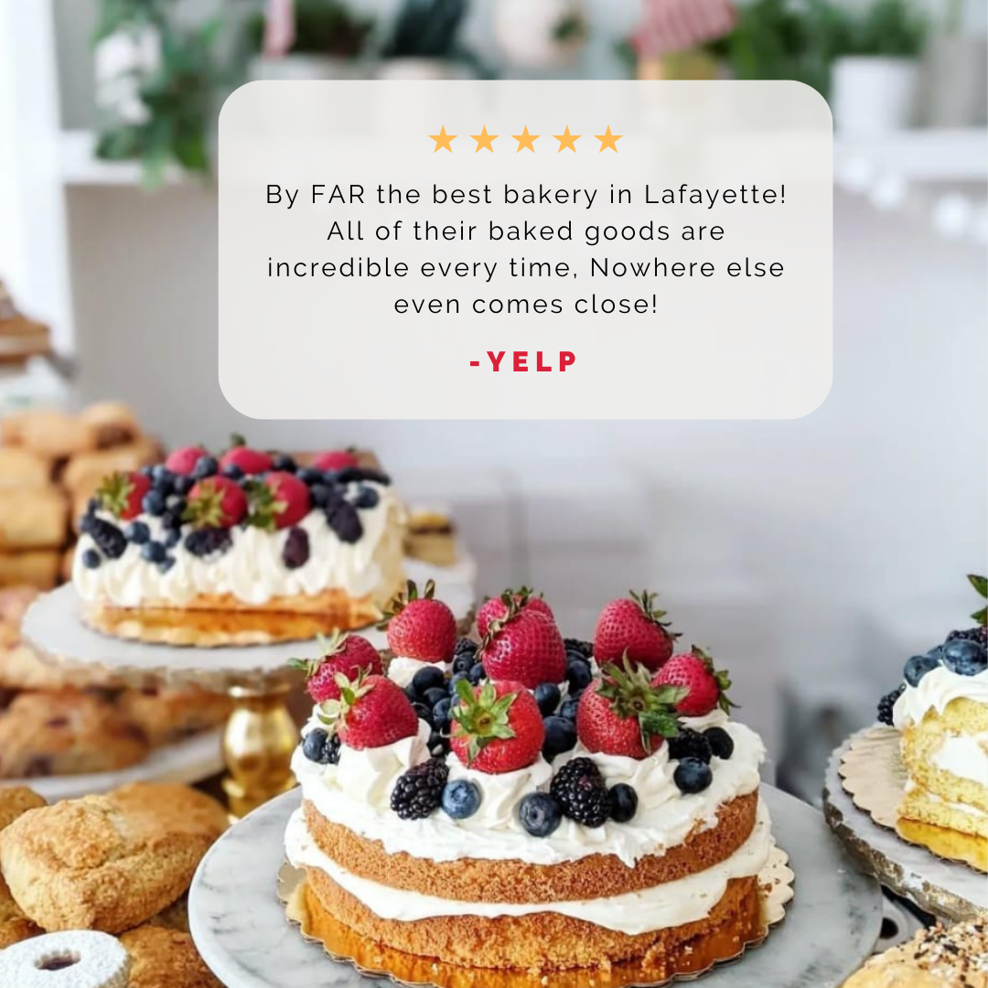

Figure 1: Initial design of ads, left: control and right: test

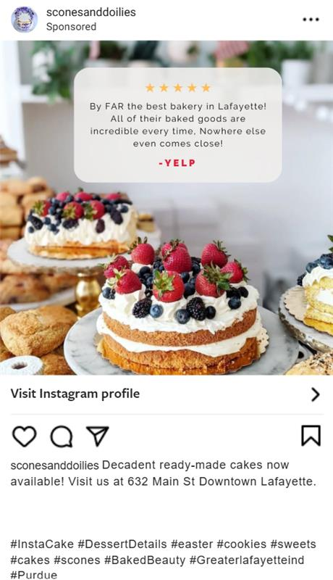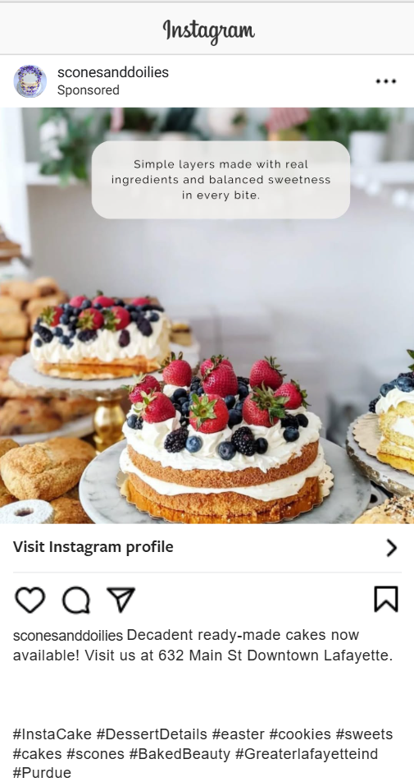

Figure 2: Finalized Ads, left: control and right: test

**Appendix III - Performance and Engagement Metrics**

Figure 1: Consolidated metrics

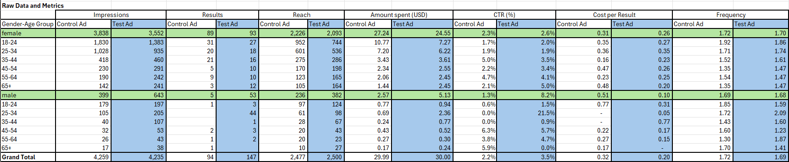

Figure 2: Consolidated metrics as percentage of total

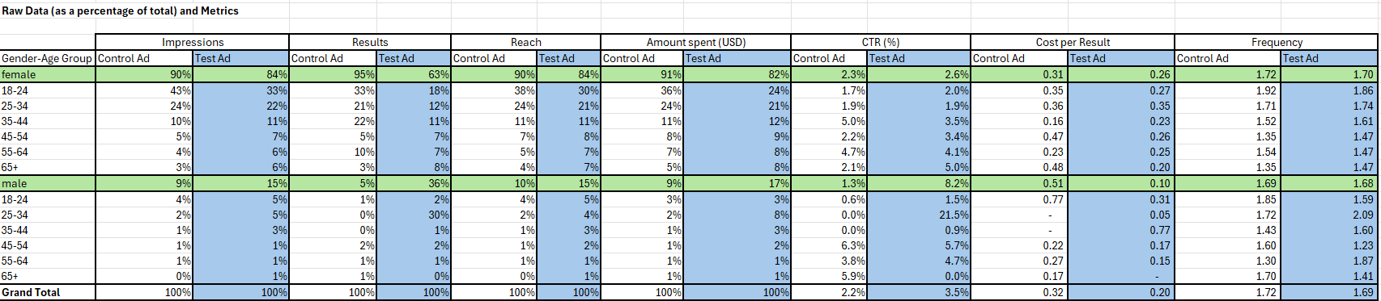

** ~1% of the data was for gender “Unknown”, which has been ignored in this analysis as the data points were too less to draw statistically significant insights.

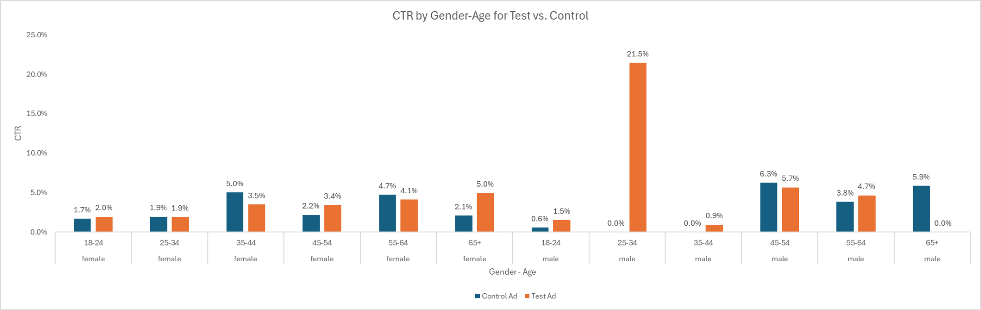

Figure 3: Click through rate by gender-age for test vs control

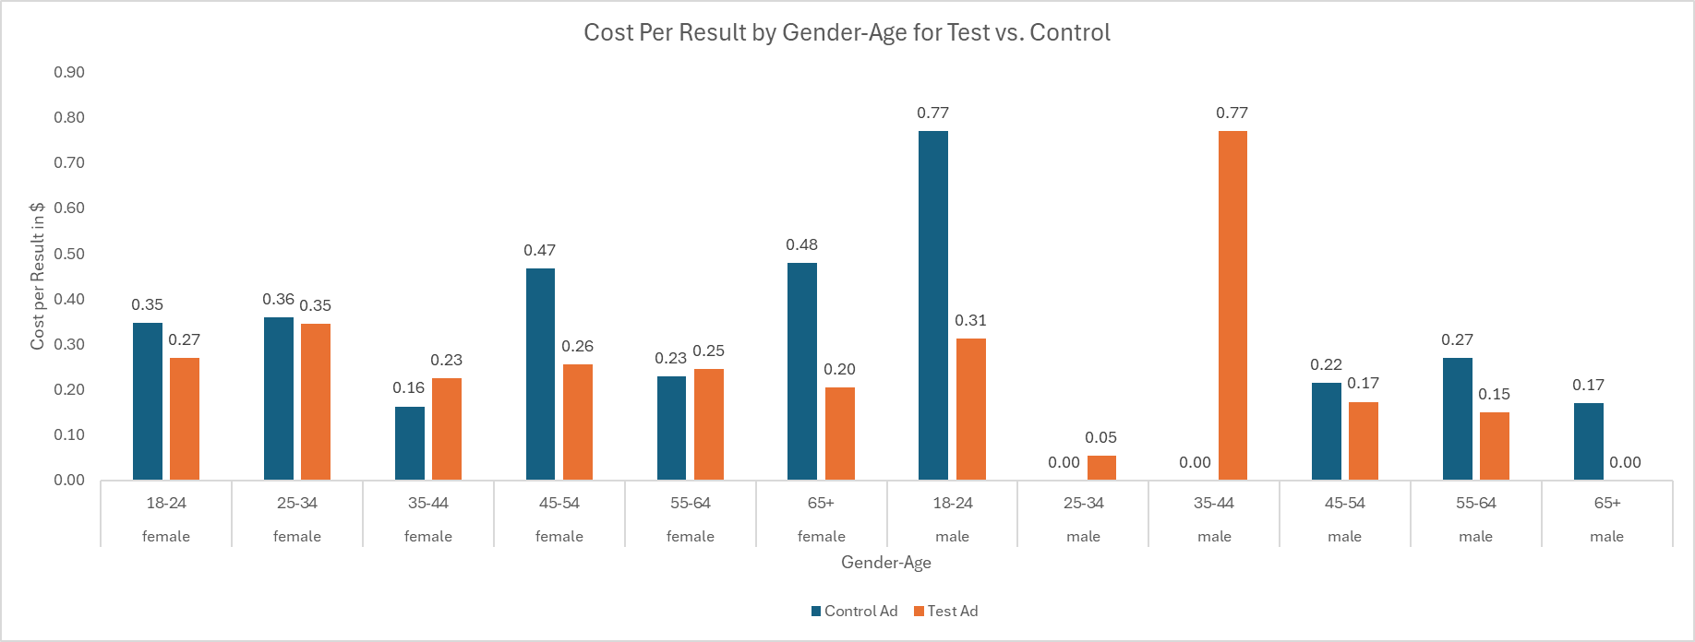

Figure 4: Cost per result by gender-age for test vs control

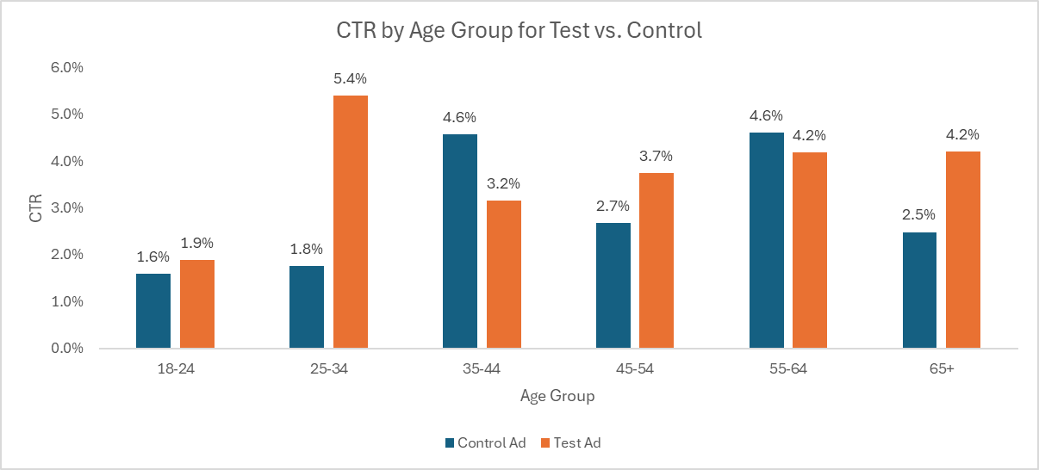

Figure 5: Click through rate by age for test vs control

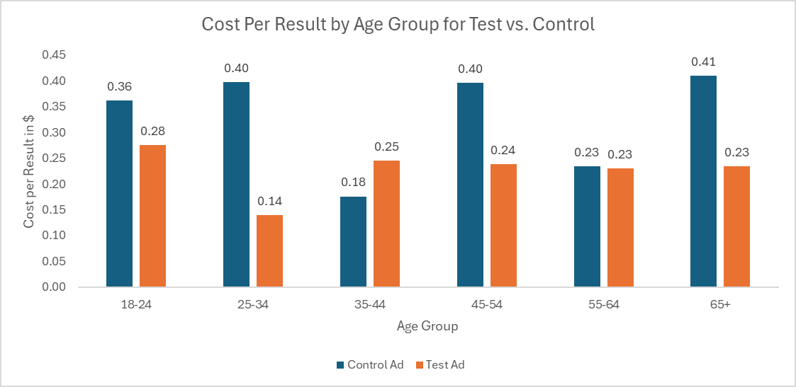

Figure 6: Cost per result by age for test vs control

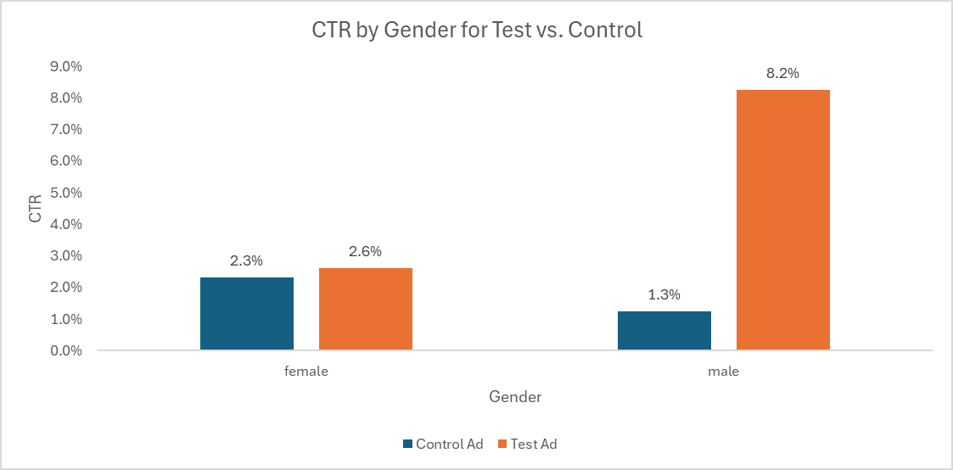

Figure 7: Click through rate by age for test vs control

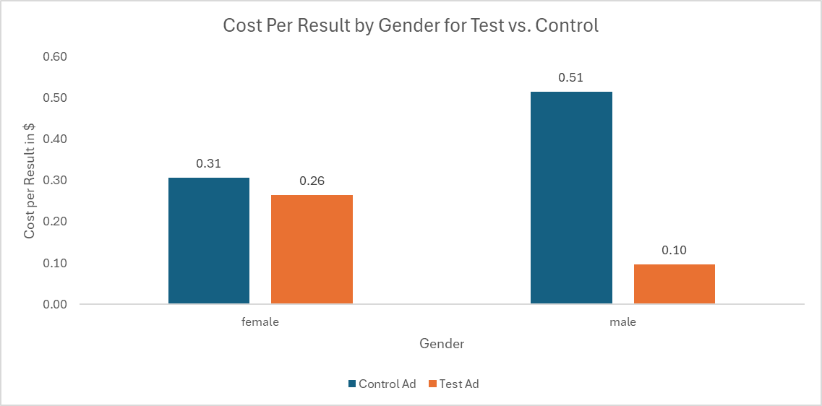

Figure 8: Cost per result by gender for test vs control